**Using this program.**

1. Click the "Open" button to open the simulation project.

2. Click the button which you want to add to the steering panel.

ex) To add the temperature panel, click the "temperature panel" button after inputing the initial values.

3. You can change the initial values and add to the steering panel at any time

warning) On the case of "Dimension", you can't add to the steering panel. You can set the values to XML file by clicking the "Dimension".

**Example**

Let’s suppose the project named “steering_panel_demo”.

And let’s suppose that we add the temperature panel to this simulation.

This simulation project includes the folder named “Simulation”.

In this folder, there are some main files such as “_setting.sqlite”, “steering_panel_demo_steppables.py”, “steering_panel_demo” and “cellsort_2D.xml”.

Now we must add some codes to these files except “_setting.sqlite”.

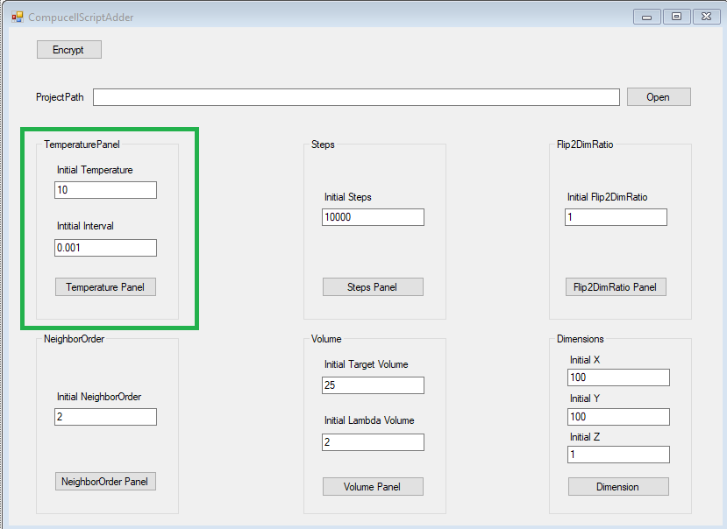

To add temperature steering panel, you must click “the temperature panel” button after input the “Initial Temperature” and “Initial Interval”.

Let’s look at the “cellsort_2D.xml” file.

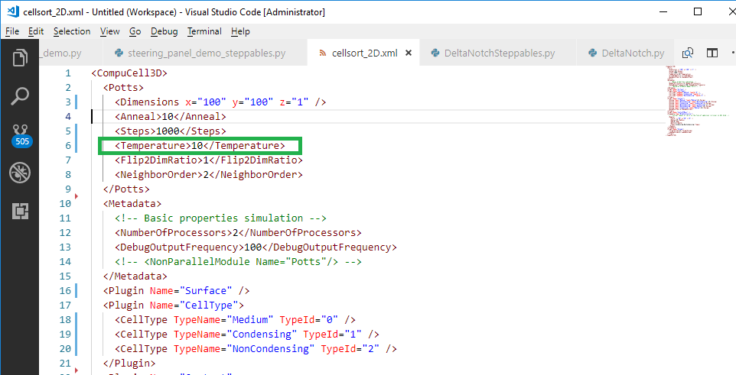

As you can see the picture, the Temperature tag’s value of the xml file is changed.

This is the initial value of the simulation.

And let’s look at “steering_panel_demo_steppables.py”.

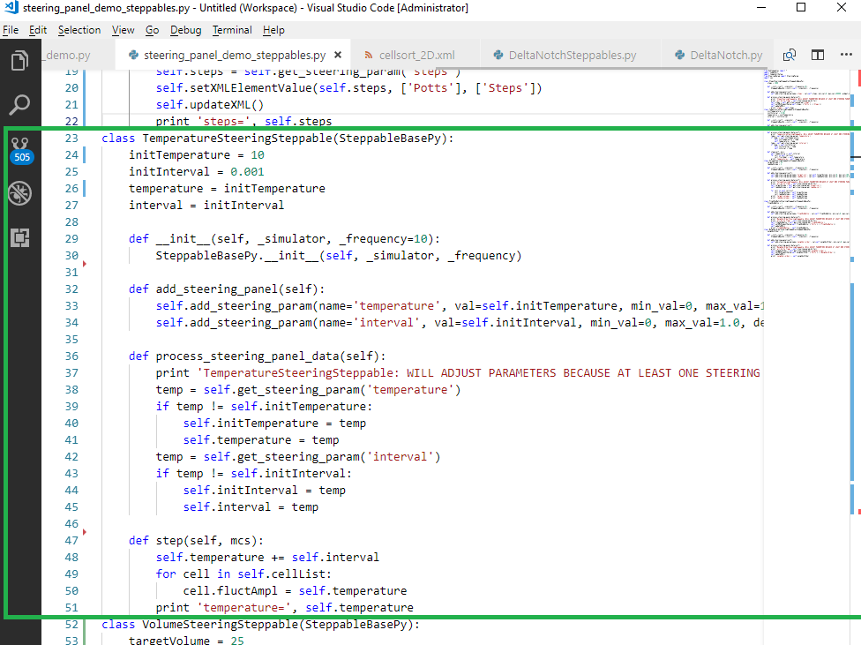

And as you can see the picture, the “TemperatureSteeringSteppable” class is add to the”steering_panel_demo_steppables.py” file.

Here, you can add the log print feature to step(self, mcs) and process_steering_panel_data(self).

Now I added the log feature to step(self, mcs) in this picture.

And let’s look at the “steering_panel_demo.py”

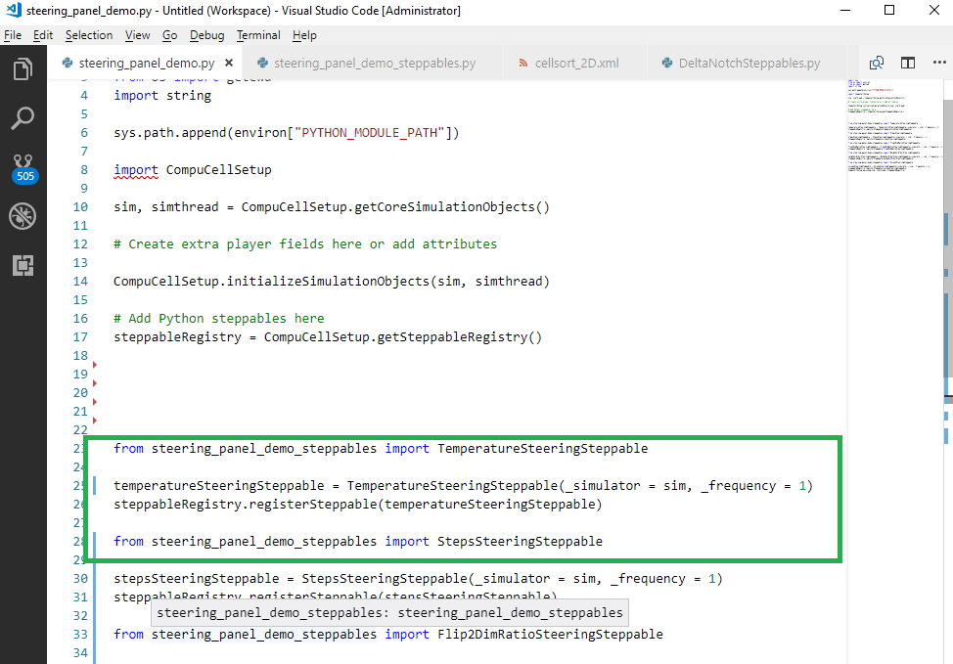

The highlighted part is the code to show the temperature panel.

This code is added to the “steering_panel_demo.py”.

By now, I explained the added codes after clicking the “TemperaturePanel” button.

I have included the “steering_panel_demo” project.

You can see the codes on all panels and change the script.

After you use my program, you can change the script manually.

Of course you must be able to know about the python script.

Thank you for your reading. And please apologize my poor English skill.